Business Case Study

China Silk Inc.

Prepared by Steve Clarke (MBA, PhD, ABD)

June 5, 2012

Introduction
The purpose of this paper is to examine the impact of globalization on The People’s Republic of China (PRC) as it influences multinational corporations (MNC) management strategies going forward. Further, to investigate and explore the MNCs international strategic management and decision-making process when entering or expanding business in China. Analysis will include markets, investment, production, and technology as they influence strategic categories of culture, ethics, economics, politics, strategic alliances, human resources, supply chain, distribution channels, and financial management. For the purpose of this paper, the MNC is a global brand; China Silk Inc. (CSI) China Silk Inc. management is looking to add China as both additional sourcing and as a consumer market as part of their global strategy. China Silk Inc. is planning to open a subsidiary in China based on research and investigation through this analysis. Understanding and strategic planning for China is unique, as “The Chinese model of development in globalization is far from being a successful model applicable to other developing countries” (Yue, 2012).

Analysis
Globalization is the flow of technology, economics, knowledge, people, values, products, and services across borders. “Globalization should be understood as a multi-pronged process, since deterritorialization, social interconnectedness, and acceleration manifest themselves in many different (economic, political, and cultural) arenas” ("Globalization," 2010). This analysis will focus on the strategic concepts, and approaches for consideration by CSI’s management based on these global elements and trends. It should be noted at the beginning and detailed consideration given by CSI as to the relationship between China and the US as they both participate in the World Trade Organization (WTO). Since China’s 2001WTO accession, China has been the target of 29 WTO trade disputes, with the United States accounting for the lion’s share of these cases, a number of which restrict foreign market access to China (Zeng, 2013). CSI is a US corporation, currently selling wine in the US, Europe and Australia. CSI wine is currently produced under contract with a winery in Xinjiang, China (Suntime Int. Ltd). Management will evaluate the China market opportunity based on a transnational strategy, incorporating local adaptation, efficiency and a learning curve as it relates to China’s maturation as a developing market and as it attaches to both wine production opportunities in the retail brand development, all addressing significant Chinese cultural elements through localization and customization approaches.

Economic, Social and Political
CSI’s management strategic positioning starts with an overview of China’s economic environment, which offers a positive foundation for MNCs business potential, based on China’s continued trend of projected GDP thru 2014 as seen in Table 1. Further, most projections of China’s GDP at market prices is likely to exceed the US in the period 2017-2021.

Table 1
Overview of GDP for the United States and China Economic Projections

 |  |  | Projections |  | Differences from October 2012 WEO Projections
 | 2011 | 2012 | 2013 | 2014 | 2013 | 2014
United States | 1.8 | -.04 | -0.2 | 1.0 | -0.1 | 0.1
China | 9.3 | 7.8 | 8.2 | 8.5 | 0.0 | 0.0
Global | 3.9 | 3.2 | 3.5 | 4.1 | -0.1 | -0.1
Source: (International Monetary Fund, 2013)

China’s Real GDP growth, as seen in Figure 1, The PRC leads the global community at a projected 8.5% through 2017. Further merchandise trade for 2011 reflects China’s continued import and export global share. The 2012 KOF Index of Globalization for 2012 reflects the United States at 74.88 (ranked 35) and China at 59.37 (ranked 73) out of the 208 countries ranked globally. The KOF index defined as the globalization process of creating networks among companies at multi-continental distances, facilitated through a variety of flows including people, information and ideas, capital and goods (Keohane & Nye, 2000). This index is calculated on a one to hundred scale, with the higher the value representing the greater the globalization, based on components of economic, political and social globalization factors, which requires careful analysis of the China market for CSI as follows:

- Economic globalization, characterized as long distance flows of goods, capital, and services, as well as information and perceptions that accompany market exchanges – FDI inflows have provided state of the art wine making equipment in a number of wineries around China, offering CSI opportunities for production. One distinctive advantage for CSI as a retail brand in China is the avoidance of import duties, tariffs and/or other restrictive and cost augmenting elements.
- Political globalization, characterized by a diffusion of government policies - CSI has hired the previous commerce commissioner of Shanghai to help in the personal contacts, information gathering and flows, interpretation and cultural education and adaptation. He is currently a paid consultant; however, as CSI sets up the China Silk China (CSC) subsidiary, the consultant will become a direct hire and added to the CSC board of directors. The management structure for the China subsidiary will follow an ethnocentric-international model, while CSI remains headquarters in US, China subsidiary headquarters in Shanghai and production office in Urumqi, to oversee current wine production facilities at Suntime. An exception to this will be a matrix structure position oriented towards the CSI wine maker, working in China and the US, reporting to the CSI CEO. The CSC CEO has 30 years’ experience in the China as a brand consultant and manufacturer, in addition to US senior retail management, which will support the local experienced managers.
- Social globalization, expressed as the spread of ideas, information, images, and people –The CSI wine maker is from Australia and is recognized worldwide, working with the head wine maker at China winery (Suntime). The CSI winemaker brings his personal experience of wine making at Kendall Jackson, in addition to the experience of the Suntime wine maker, trained in France, providing “new world” recipes and methodologies in wine making.
Adapted from the (KOF Globalization Index, 2013)

International trade data analysis globally, and between China and the US provides understanding and planning considerations as to materials, import duties, tariffs, regulations, and other cost, logistical and supply/demand products for CSC’s retail brand development and competition from imported western wines. Strong trade relations for the CSI network supports the firm’s requirements for materials and as a foundation for the growing competitive retail wine market, reflected in the wine imports found in Table 2. Further wine consumption per capita growth also supports the China market brand opportunities. While the grapes are grown for the wine in China, the bottles are imported, as well as new machinery, such as state of the art bottling machinery, French vanilla casks, and stainless steel tanks, as seen in Appendix C. These investments by the China owned wineries reflects the long-term strategic development plans for the China market and for export, supported by the #2 global ranking in stock of direct foreign investment home reflected in Table 3.

Production/Manufacturing, Consumer Market, and Marketing
CSI contract production with Suntime provides benefits to the winery in the production of wine regarding quality, design of packaging and labels from western designers at CSI, to local distribution market information through Suntime networks. “In face of the MNCs possessing global market, global brand, and global procurement systems, indigenous firms were unable to compete on the global level playing field established on China’s home market. Within the globalized international division of labor, they increasingly depended on the importation of “designs, critical components and manufacturing equipment” from the advanced economies” (Yue, 2012, para. 8).
The success for the China consumer market of product-oriented brands will come from product innovation aimed at avoiding commoditization and retaining pricing power (Kalish, 2009, p. 2). The retail pricing strategy for the China market will not be cost leadership, but instead, affordable value leadership, based on the goal of creating enhanced brand equity of “new world wines” (wines from the New World are from non-European countries such as South Africa, New Zealand, and the United States
(fruit forward in flavor) produced for China.
While Chinese consumers are price sensitive, they also have strong interest in the other attributes of products and are willing to pay premium prices. CSC will price in the low moderate price range of the overall competitive retail wine market. As CSC will not have import duties and fees, that total 48% for China imported wines. CSC prices target positioned for the Chinese fashion conscious growing urban income target market as seen in Figure 3. While the overall food (includes wine) category of household annual consumption goes down as a percentage to total, pure expenditures in dollar volume increases substantially (.64 $ trillion in 2000, to 4.38 $trillion projected 2020) as seen in Figure 4. Made in China will not be a priority component of marketing, packaging, or sales. A key component of the marketing and product development will focus on not replicating products currently offered, but providing international award winning “new world “wines in contemporary Chinese label designs geared to the growing consumer purchasing patterns towards western fashion and merchandise.
The expansion of China’s economy will be concentrated largely in its mushrooming cities, 14 of which will appear on the list of the world’s top 25 cities in terms of absolute GDP growth for the next decade (Atsmon, Magni, Li, & Liao, 2012, p. 11). This urban growth provides the foundation for the strategic alliances and structures focusing on the hypermarkets in these major cities. An additional aspect of the China consumer market is the after-sales support the CSC will need in place, at each level of consumer related activities including the political aspect of government oversight into foreign brands. The issue of Apple’s China campaign that caught the Chinese government’s attention, accusing Apple of incomparable, and arrogant, provides an example, warning Apple it would face “severe repercussions if it did not improve its after-sales services” (Gosden, 2013, para.4).
Currently, most of the Chinese traditional media, like newspapers, magazines and news agencies, are government owned and widely scattered. In addition, CSC marketing will target market within the initial cities of Shanghai and Beijing. While censorship is a major issue facing western firms in China, wine is not illegal or controlled as to marketing. Today China has 485 million active internet users. Microblog is the leading blog site increasing users from 63.11 million to 195 million during the first half of 2011. Additionally, there is also a strong trend towards mobile media. By mid-2011, China had over 920 million mobile users, according to data released by China’s Ministry of Industry and Information Technology. CSC marketing focuses on these technology-marketing trends in addition to strong point-of-sale presentation at each retail site, matching traditional promotional calendars with particular attention and expenditures during the Chinese New Year holiday season. Lastly, CSC plans include customer direct internet sales of China Silk wines, legal in China, only legal in 17 USA states, offering a major opportunity for the brand development in China.

Culture
Culture is a dominant difficulty for CSC management negotiations in China and it plays an essential role in all activities between the multiple strategic alliances, including production, distribution, human resources, and legal issues. “The impact of the psychological states of the negotiators, the social conditions of negotiations, and the behavior of negotiators on the outcomes of negotiations differs from country to country” (Huang & Van de Vliert, 2004, p.471). Of all the CSC management endeavors to open the China market, culture is the most overriding and critical factor best described by And Fang, (2006) maintains that the core of the Chinese negotiation style is a “blend of Maoist bureaucrat in learning, Confucian gentleman, and Sun Tzu-like strategist” (p. 54).
As a Maoist bureaucrat, the Chinese negotiator follows his government’s plans for doing business. He gives first priority to China’s national interest and never separates business from politics. He avoids taking initiatives, shuns responsibility, fears criticism, and has no final say. Being a Confucian gentleman, the Chinese negotiator behaves based on mutual trust and benefit, seeking cooperation and win-win solutions for everybody to succeed. He places high value on trust and sincerity on his own part and that of the other party as a human being. For him, cultivation of righteousness is far more important than the pursuit of profit. He shows a profound capacity to conclude business without negotiating. As a Sun Tzu-like strategist, the Chinese negotiator sees negotiations as a zero-sum game and the marketplace as a battlefield. He sets out to win-lose you. He never stops bargaining. He is a skillful negotiator. Moreover, at the heart of his bargaining techniques lies Sun Tzu’s stratagem to subdue the enemy without fighting. (Fang, (2006, p. 54).
Guanxi (personal connections) is the overriding methodology in Chinese negotiations. The root cause of negotiation breakdowns between Chinese and American business managers is a failure on the American side to understand the much broader context of Chinese culture and values, a problem that too often leaves American negotiators both flummoxed and flailing(Graham & Lam, 2003, p. 2). This is the major reason CSC will hire a former government official and add to the CSC board of directors. His experience, networking, and leadership in developing successful negotiations are imperative for the success of CSC in the China market.

Ethics
As mentioned, negotiations are critical as to the foundation of almost all areas of CSC activities in China, with ethics providing a critical component. “Nowhere is the gray line between what is ethical and what is not ethical apparent than in bargaining and business negotiations” (Ma, 2010, p. 123). An interesting example facing CSI and CSC in China is the Foreign Corrupt Practices Act (FCPA) of 1977. The bribery of foreign officials is illegal for any US company doing business overseas, however, in China, this practice is not only legal, is considered ethical. However, the FCPA) does allow for payments, if they are not for any advantages, but are for the normal process and work done by the official. The specific payment in this example is the payment for an export license, which is a normal fee, even though it is paid directly to the government export manager. It is part of Guanxi, personal networking. Companies operating in China must prepare and support a system and set of procedures for dealing with bribery (little red packets) and/or requests for bribes, taking the pressure off employees and management in negotiations and during social relationship meetings, considered a strong component of Guanxi.

Strategy (Strategic Alliances)
The structural choices of the CSI subsidiary will follow a strategy progression for the division of tasks, integrating activities and authority because of the manufacturing and retail classification for the China market development. The different categories require different duties and responsibilities. CSC will enter a contract manufacturing relationship with the winery, in order to allow for expanded sourcing opportunities as needed going forward. CSC will form a joint venture approach with a wine distribution firm currently well positioned with marketing channels as an industry leader with the hypermarket retail community that sells the majority of wine in China, including Carrefour, Wal-Mart, Lianhua, and Tesco (Wang, Liu, & Wang, 2012). Wine in China is unique in that, due to the presence of a community of specialized distributors, most of who act as exporter, importer, and distributor all in one, taking product directly to retailers and food service venues. This represents a significant difference with the American model, which is individual by state, and laws and regulations prohibit firms participating in more than one activity, such as importer/exporter, distributor, and retailer.
An additional approach for CSC includes a modular organizational system of outsourcing legal and retail marketing activities. Further, CSI management and CSC management form an ambidextrous organization design plan, to pursue modest incremental innovation in both wine making for the global market, while creating a dramatic introduction into the China retail market (Dess, Lumpkin, & Eisner, 2020, p. 375). CSI currently enjoys wine production and wine label international awards that provide a cultural connectivity to the China market, through credibility and Chinese western products, made for China (Petavy, 2011). As Mr. Chen (Former Shanghai Commerce Commission) currently consulting, and will join the CSC board of directors, his expertise and retail networking provide CSC a competitive advantage.

Human Resources (Expatriates & Organizational Structure)
A significant issue in human resources for China is that of human capital, the ability to execute a strategy that is dependent on finding and retaining good quality managers for those key CSC positions, in particular the network oriented distribution and marketing elements, while assimilating the US and China corporate cultures (Kalish, 2009, p. 6). CSC will endeavor to adjust the combined corporate environments in balance between headquarters and the subsidiary, or functional structure approach, benefitting from the individual strengths. The CEO of CSC will be an American expatriate, while the other department heads will be from the local China business community. While CSI maintains an overall centralized organization, a degree of decentralization for the CSC management, with local Chinese board member/s will allow for adjustments to China’s cultural and specific business related activities, such as legal, regulatory, and the balance of business model activities. The coordination of the headquarters and subsidiary management team’s strategic controls result from monthly meetings, through international travel and the use of technology such as live online meetings and discussions. Direct interaction by US legal counsel and accounting management, with the CSC legal counsel and accounting will deal with the China regulations for both areas as to control and compliance.
Human resources management for CSC employees in China is an evolving and critical factor in the company potential for success. The General Office of the Communist Party of China (CPC) Central Committee has been playing a key leadership role for both government and private industry, with a special focus on foreign human resources management. CSC will develop a key relationship with the CRC local offices. The CRC also encourages the utilization of modern technological measures, such as the Internet and information technology, in human resources management ("CPC Human Resources Mgmt," 2012). CSC management will work with the American Chamber of Commerce in conjunction with the CRC, to develop the human resources policies and practices for the subsidiary. CSI management will work with local Shanghai and Beijing HR firms to develop effective programs for the selection, and retention of talent practices. Additionally, CSI will invest in every employee by providing the tools and authority for employees to learn and in fact, solve problems, leverage opportunities and contribute to the company and their individual careers.

Supply Chain and Distribution Strategies
CSI currently has in place, a supply chain for providing the China production of wine (made with China grapes) in the Urumqi winery, with bottles, labels, and corks. Additionally, the logistics system for moving the finished wine to Shanghai and Beijing, on the eastern coast of China, a distance of about 3,000 miles from the winery, is working efficiently. Careful planning and decision making for logistics of wine include the cold storage requirement for trains, trucks and in exports, for ocean freighters. This transportation system will support the planned China distribution strategies focused on the same two major cities, which are the primary initial target markets. Distribution in China is improving. Business executives have experienced directly and through communications networks, horror stories concerning the movement of goods, however, these instances are becoming fewer and fewer (Kalish, 2009, p. 6). The supply chain and distribution strategies for CSC “In a country where all assets were theoretically public just a few decades ago, it is hard to find a long-standing business with an entirely clean record” ("Managing Risks in China", 2007). This financial issue is ongoing and a major consideration in the China market development. As a result, the supply and distribution strategies for CSC will be structured through an annual year-to-year contract system instead of joint venture.

Financial Management/Accounting
CSI and CSC are required to meet both the US and China’s accounting practices, which requires the support of a locally trained accounting team for CSC, communicating and working with the headquarters team to insure compliance as required. Even though China joined the WTO, which requires members follow WTO rules on validity and standard accounting procedures, China accounting practices need to improve, such as promoting the standardization of accounting, internationalization of accounting business practices (Ding & Hall, 2012, p. 246). While accounting will be centralized overall, from headquarters, the China accounting manager will have a dotted line responsibility in reporting to CSI accounting vice president.
Renminbi index and considerations for CSI and CSC reflect a minor issue as the exchange rate over the long-term has been minimal in variance to the US dollar. Since production of CSC wine is in China, duties on materials such as bottles, corks are very low, and there is no duty on labels. The impact of exchange rate is not significant to the China market development plans for the retail brand.
Legal resolutions - A key focus for CSC management, because of owning the China Silk wines recipes, and packaging designs includes attention to data theft, and intellectual property rights. Many of the WTO disputes involve intellectual property rights. The WTO Agreements on Trade-Related Aspects of Intellectual Property Rights (TRIPS Agreement) requires China set up “enquiry points” providing CSC a door to potential disputes on labeling and wine production. CSC will engage a Shanghai international law firm for production, distribution and retail-market contract negotiations, implementation, oversight, and any litigation support that may become necessary. The winery is state of the art, providing the foundation for extremely clean working conditions for employees. In addition, the nature of wine making as to requirements for high quality wines is also conducive to exceptional working conditions, beyond the normal WTO and/or US human rights requirements.

Conclusion
As CSI expands into the China market with the start-up of CSC as a subsidiary, the influences of globalization factors require research, understanding, and a strategic development plan that incorporates all aspects of economic, political, and cultural elements. CSI expects continued economic prosperity in China for the near future, supporting the target market approach, starting with Shanghai and Beijing. Production and marketing of “new world” wines, made in China, for the China market through customized packaging and marketing media present a strong foundation for success. The CSC organizational structure balances a transnational methodology, between an expatriate CEO (US) and an important board member with extensive China business experience in wholesale, retail, and network proficiencies. Supply and distribution channels currently in place, provide the foundation for local China market development. Financial management and accounting will balance China, US, and WTO requirements between home and cost country divisions. The experience of expatriate and local management should provide a strong foundation for success for the CSI subsidiary, China Silk China.

References

Atsmon, Y., Magni, M., Li, L., & Liao, W. (2012). Meet the 2020 Chinese consumer. Retrieved from http://www.mckinseychina.com/wp-content/uploads/2012/03/mckinsey-meet-the-2020-consumer.pdf

Boyce, J. (2012). China Wine Import Stats. Retrieved from http://www.grapewallofchina.com/2012/02/08/china-wine-import-stats-for-2011-are-out-and-france-crushes-the-competition-again/

CPC stresses human resources management. (2012, September 9). Xinhua. Retrieved from http://news.xinhuanet.com/english/china/2012-09/26/c_131875045.htm

Dess, G. G., Lumpkin, G. T., & Eisner, A. B. (2020). Strategic Management (5th ed.). NYC, NY: McGraw Hill Irwin.

Ding, J., & Hall, S. (2012, February). Effects on the Chinese accounting industry from joining the World Trade Organization. Proceedings of ASBBS, 19, 241- 246. Retrieved from http://asbbs.org/files/ASBBS2012V1/PDF/D/DingJ.pdf

Fang, T. (2006). The Chinese style. The Journal of Business & Industrial Marketing, 21(1), 50-60. Retrieved from February 06, 2012

Globalization. (2010). Retrieved from http://plato.stanford.edu/entries/globalization/

Gosden, E. (2013, April 1). Apple chief Tim Cook apologizes to China over customer service. The Telegraph. Retrieved from http://www.telegraph.co.uk/technology/apple/9965447/Apple-chief-Tim-Cook-apologises-to-China-over-customer-service.html

Graham, J. L., & Lam, N. M. (2003). The Chinese Negotiation. Harvard Business School. Retrieved from Retrieved from http://www.globalnegotiationbook.com/Joh-Graham-reseearch/negotiation-v1.pdf

Griffin, R. W., & Pustay, M. W. (20120). International Business (7th ed.). Upper Saddle River, NJ: Prentice Hall.

Hill, C. W. (2011). International business: Competing in the global marketplace (8th ed.). [Kindle Version]. Retrieved from www.amazon.com

Huang, X., & Van de Vliert, E. (2004). A multilevel approach to investigating cross-national differences in negotiations processes. International Negotiation, 9(3), 471-484. http://dx.doi.org/10.1163/157806053498724

International Monetary Fund. (2013). http://www.imf.org/external/pubs/ft/weo/2013/update/01/index.htm
KOF Globalization Index. (2013). http://globalization.kof.ethz.ch/static/pdf/method_2013.pdf

Kalish, I. (2009). China’s consumer market: What next? Deloitte Research, 1-28. Retrieved from http://www.deloitte.com/assets/Dcom-MiddleEast/Local%20Assets/Documents/Industries/Consumer%20Business/me_consumer_business_china_consumer_report_09.pdf

Keohane, R. O., & Nye, J. S. (2000). Governance in a Globalizing World. Washington D.C.: Brookings Institution Press.

Ma, Z. (2010). The SINS in business negotiations: Explore the cross-cultural differences in business ethics between Canada and China. Journal of Business Ethics, 91, 123-135. http://dx.doi.org/10.1007/s10551-010-0571-5

Managing risks in China - Bribery, corruption, and Little Red Packets. (2007). China Law & Practices. Retrieved from search.proqeust.com.proxy1.ncu.edu/docview/224817302?accountid=28180

Office of the United States Trade Representative. (2012). http://www.ustr.gov/countries-regions/china

Petavy, F. (2011, July 26). 4 misconceptions that can ruin your product launch in China [Journal Article]. Business Insider. Retrieved from http://articles.businessinsider.com/2011-07-26/strategy/29960132_1_chinese-culture-chinese-consumers-chinese-market

Porter, M. E., & Rifkin, J. W. (2012, March). The looming challenge of competitiveness. Harvard Business Review, 90(3), 54-62. Retrieved from http://ehis.ebscohost.com/ehost/pdfviewer/pdfviewer?vid=5&sid=48ba23d1-6b33-480a-b293-dfb59dc85d0e%40sessionmgr111&hid=110>

The Richest.org. (2012). http://www.therichest.org/world/worlds-largest-economies/

Torres, J. A. (2010). Understanding the influence and approaches to effective Chinese negotiations. The Business Review, Cambridge, 14(2), 104-112. Retrieved from http://www.torres-international.com/files/Understanding_the_Influence_and_Approaches_to_Effective_Chinese_Negotiations.pdf

Wang, L., Liu, M., & Wang, T. (2012). China Retail Report (12806). Washington, DC: Government Printing Office.

World Trade Organization. (2012). http://www.wto.org/english/res_e/statis_e/its2012_e/its2012_e.pdf

Yue, J. (2012, May 24). What does globalization mean for China’s economic development? Global Policy. Retrieved from http://www.globalpolicyjournal.com/blog/24/05/2012/what-does-globalization-mean-china%E2%80%99s-economic-development

Zeng, B. (2013). China, America, and the WTO. Retrieved from http://thediplomat.com/china-power/china-america-and-the-wto/

Zhuoqiong, W. (2012). Wine imports give Chinese firms a hangover. Retrieved from http://www.chinadaily.com.cn/bizchina/2012-08/14/content_15673957.htm
Appendix A

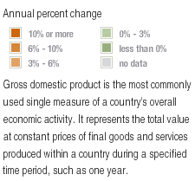 | 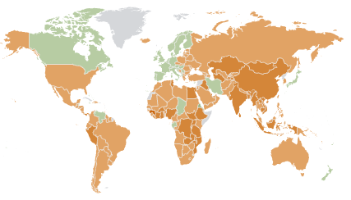
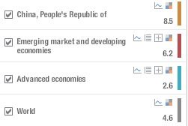 | 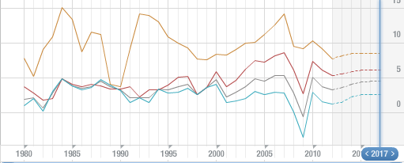
Figure 1 World Economic Outlook Real GDP Growth
Source: (International Monetary Fund, 2013)

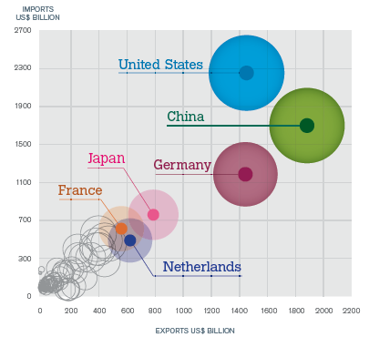
Figure 2 Leading Economies of Merchandise Trade, 2011
Source: (World Trade Organization, 2012)

Appendix A (Continued)

Table 2

Trade Data for China Global and US Trade

China and Global

Exports* | $2.05 Trillion, (2012 Estimate) ranking # 2 globally
Imports* | $1.817 trillion (2012 est.) ranking # 3 globally
Wine Imports** | Liters (Millions)  2009 2010 2011  France 40.6 68.8 117.9  Australia 18.7 23.8 37.2  Spain 4.6 9.5 19.0  Italy 6.3 11.2 18.9  Chile 6.8 10.5 17.5  United States 6.3 9.2 12.3  Source: (Boyce, 2012)
Wine Exports | Data not available
China Wine Consumption** | Per capita wine consumption was less than 0.5 liters in 2010, while the global average was 7 liters, according to the 12th Five-Year Plan (2011-15) for the Wine Industry published by Ministry of Industry and Information Technology and the Ministry of Agriculture.
China Wine Production** | By 2015, wine production in China is expected to reach 2.2 billion liters, an increase of 100 percent, at an annual growth rate of 15 percent, according to the plan.
China and the United States

Total Trade*** | U.S. goods and services trade with China totaled $539 billion in 2011. Exports totaled $129 billion; Imports totaled $411 billion. The U.S. goods and services trade deficit with China was $282 billion in 2011.
Exports*** | China was the United States 3rd largest goods export market in 2011.
Imports*** | China was the United States largest supplier of goods imports in 2011.
Trade Balance*** | The U.S. goods trade deficit with China was $295.5 billion in 2011, an 8.2% increase ($22.4 billion) over 2010. The U.S. goods trade deficit with China accounted for 41% of the overall U.S. goods trade deficit in 2011.
Investment*** | U.S. foreign direct investment (FDI) in China (stock) was $60.5 billion in 2010 (latest data available), a 21.4% increase from 2009.
* (Zhuoqiong, 2012)
** (CIA World Factbook, 2013)
*** (Office of the United States Trade Representative, 2012)

Appendix A (Continued)

Table 3

China Economic Data

Measure | China
Population * | 1,349,585,838 (Est. July 2013)  #1 Global Rank
Unemployment Rate ** | 6.4% (2012 est.)  #66 Global Rank
GDP – Real Growth Rate ** | 7.8 % (2012 est.)  # 18 Global Rank
GDP – Per Capita ** | $9,100 (2012 est.)  # 122 Global Rank
Labor Force ** | 795.4 Million  #1 Global Rank
Investment Growth ** | 47.8 % of GDP (2012 est.)  #2 Global Rank
Debt External** | $770.8 Billion (2012 est.)  # 19 Global Rank
Inflation Rate ** | 2.6 % (2012 est.)  # 59 Global Rank
Central Bank Discount Rate ** | 2.25 % (Dec. 2012 est.)  # 110 Global Rank
Stock of Direct Foreign Investment Home ** | $1.344 Trillion (2012 est.)  # 2 Global Rank
Stock of Direct Foreign Investment Abroad ** | $502.0 Billion (2012 est.)  # 13 Global Rank
Exchange Rate **  Renminbi Yuan | 6.311 (2012 est.)
*(The Richest.org, 2013)
** (CIA World Factbook, 2013)
Appendix B

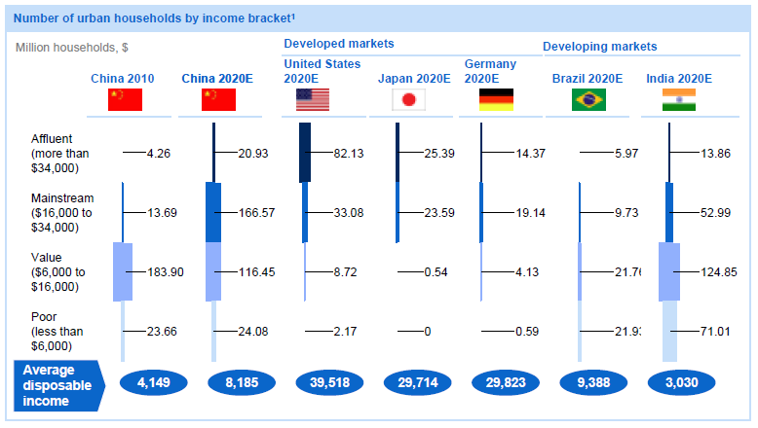
Figure 3
Source: (Atsmon et al., 2012, Exhibit 5)

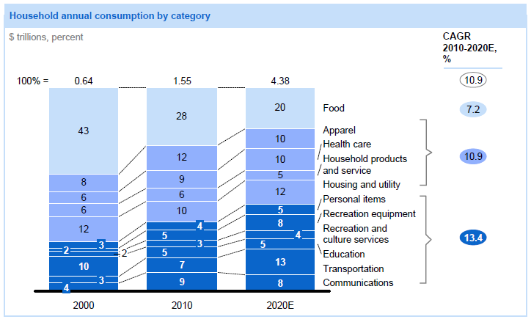
Figure 4
Source: (Atsmon et al., 2012, Exhibit 3)

Appendix

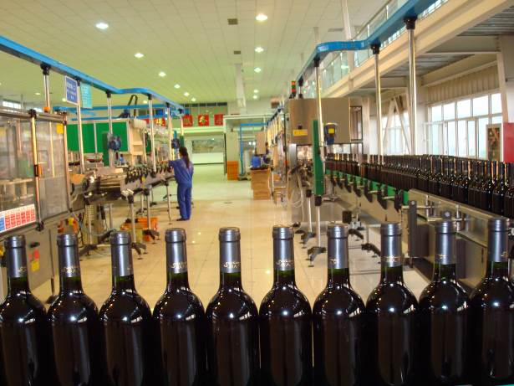  Figure 5 15,000 an hour bottling machine made in Germany | Figure 6 Stainless steel 12,000 Liter tanks made in Sweden
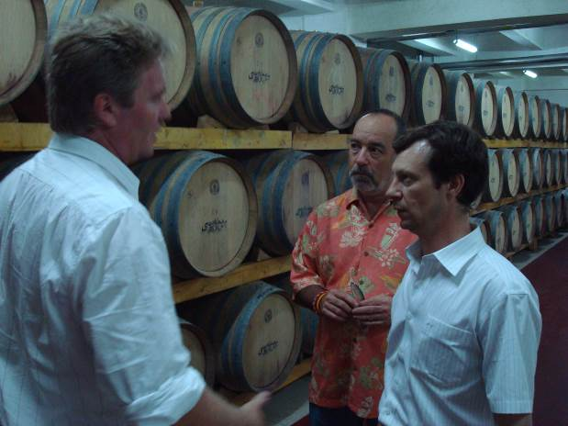  Figure 7 Vanilla Wine Casks made in France  Left – John Weeks, China Silk Wine Maker  Center- Steve Clarke, CEO China Silk  Right – Fred Neulau – Suntime China Wine Maker and General Manager | 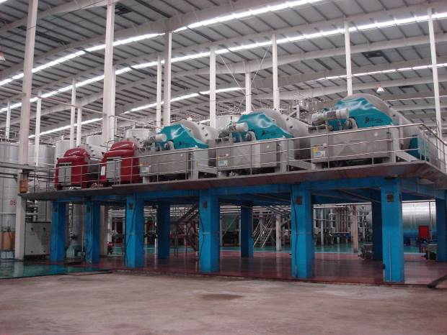  Figure 8 Generators made in USA
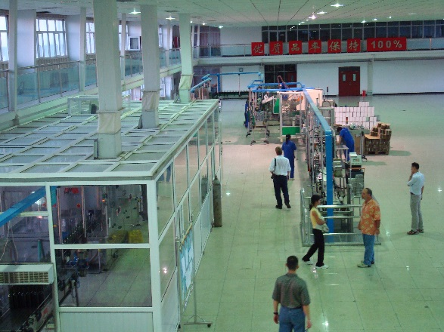  Figure 9 Bottling Room | Figure 10 Suntime Winery, Urumqi, Xinjiang, China

ABOUT THE AUTHORS
Steve Clarke (MBA, PhD, ABD) is Senior Consultant and Advisor to the Global Management Group (www.globalmanagementgroup.com), a leading consulting firm that helps US companies and executives succeed in Asia. He has consulted for Fortune 500 companies and has extensive experience in the China market. In addition, he has more than 25 years of experience in International Business at Federated Department Stores (Macy’s, Bloomingdales), May Department Stores, Carter Hawley Hale Department Stores, Eddie Bauer, National Football League (NFL), Arnold Palmer Golf Design, Central Department Stores (Thailand), Robinson Department Stores (Philippines), and #1 Department Store (China). He has also been a successful entrepreneur founding China Silk Wines, in addition to consulting foreign companies entering the Asian market. He has taught international business classes including, strategy, ethics, social media, foreign market entry, marketing, economics, organizational behavior, operations management brand development. He is a graduate of Northern Arizona University, Grand Canyon University, and Northcentral University. He is currently senior consultant for Global Management Group, International Consultants and is guest business analyst on the Nation, Sunday Night Business weekly television in Bangkok Thailand.

Professor Peng Chan (PhD) is Full Professor of Strategic Management at Cal State Fullerton. He has published widely (200+ articles) in the fields of strategy, franchising, and international business and has over 25 years’ business and consulting experience in the US and the Asia Pacific region. Dr. Chan is founder and CEO of Global Management Group (www.globalmanagementgroup.com).

Chan, Peng
Pollard, Dennis
Lee, Byung Hee
Clarke, Steve
Pub Date:
01/01/2010
Publication:
Name: Review of Business Research Publisher: International Academy of Business and Economics Audience: AcademicFormat: Magazine/Journal Subject: Business, international Copyright: COPYRIGHT 2010 International Academy of Business and EconomicsISSN: 1546-2609
Issue:
Date: Jan, 2010 Source Volume: 10 Source Issue: 1
Product:
Product Code: 8523100 Archeology; 0112000 Rice NAICS Code: 54171 Research and Development in the Physical, Engineering, and Life Sciences; 11116 Rice Farming SIC Code: 2084 Wines, brandy, and brandy spirits;

