Challenges of Multinational Enterprises Conducting Global Business
Steven J. Clarke, Global Management Group
Peng Chan, California State University-Fullerton

Abstract
The purpose of this paper is to provide a manuscript for the initial evaluation of international economic considerations facing Multinational Enterprises (MNEs) of all sizes, prior to entering a new foreign market. The problem for global business managers is the negative impact that results when foreign managers do not recognize and accommodate the differences between regional and global strategies. This paper is a qualitative narrative including relationships between firms, host governments, foreign exchange, investment decisions, and risk factors. Additionally, comparisons of motives, perspectives, and challenges that MNEs need to contemplate. For purposes of this paper, MNEs are companies that operate in two or more countries. MNEs are the key drivers of globalization. Previous research tend to focus on regional and global strategies, this paper fills a gap by focusing on the concept that international business requires regional strategies as more relevant than global strategies. Multinational enterprises/corporations, small, medium, and large, exist because certain economic conditions make it possible for the firm to profitably undertake production of a goods or services in a foreign location. Further, national population demographics, and dynamic economic development changes affect foreign markets for all firms looking to enter or expand in foreign markets. The importance of this research derives from the degree of global expansion, continuing to grow in value to global market entry by aggressive MNEs. The data supports this import showing that MNEs own most of the technology in the world, and they receive about 80% of all technological royalties and fees. The 700 largest multinational firms account for around 50% of the world R & D spending. There are more than 70,000 MNE companies worldwide, with more than half a million subsidiaries in over 100 countries. The 500 largest multinationals, account for about 25% of world products and nearly half of the world trade. (Guillen, 2011) For these reasons, the success around the world of multinational firms are seen as the leaders of modernization, consider expansion, even though some criticize them as “dogs of capitalism”. The findings reflect the void in market entry evaluation of MNE’s in understanding the complexity of fundamental economic, strategic, organizational, and sociopolitical principles. MNE success requires penetrating scrutiny, research, and careful decision-making.

MNE’s and Host Government Relationships

MNEs (including all forms of corporate structure) relationships with a host country will depend on numerous decisions leading to the selection of the host country such as; structure, vertical, and horizontal influences in all areas of foreign market entry motives, including investment decisions, production operations, licensing options, negotiations, partnerships, management strategies and demographics. Comparative advantage alone is not enough reason to expand. Each firm must decide on the strategy that best suits their situation, that is, whether to provide service and/or products in a foreign country for domestic and/or export utilization. The Organization for Economic Cooperation and Development (OECD, 2011), point to the following categories by the shared governments in which provides a very strong set of guidelines for all MNEs managers to learn and follow.

Table 1

OECD Guidelines for Multinational Enterprises for responsible business
conduct in a global context

I. | Concepts and Principles | Provide principles and standards of good practice consistent with applicable laws and internationally recognized standards.
II. | General Policies | Enterprises should take fully into account-established policies in the countries in which they operate, and consider the views of other stakeholders.
III. | Disclosure | Enterprises should ensure that timely and accurate information is  disclosed on all material matters regarding their activities, structure, financial situation, performance, ownership, and governance.
IV. | Human Rights | States have the duty to protect human rights.
V. | Employment and Industrial Relations | Enterprises should, within the framework of applicable law, regulations and prevailing labor relations and employment practices and applicable international labor standards:
VI. | Environment | Enterprises should, within the framework of laws, regulations and  administrative practices in the countries in which they operate, and in consideration of relevant international agreements, principles, objectives, and standards, take due account of the need to protect the environment, public health and safety, and generally to conduct their activities in a manner contributing to the wider goal of sustainable development
VII. | Bribery and Extortion | Enterprises should not, directly or indirectly, offer, promise, give, or demand a bribe or other undue advantage to obtain or retain business or other improper advantage.
VIII. | Consumer Interests | When dealing with consumers, enterprises should act in accordance with fair business, marketing and advertising practices and should take all reasonable steps to ensure the quality and reliability of the goods and services that they provide
IX. | Science and Technology | Endeavour to ensure that their activities are compatible with the science and technology (S&T) policies and plans of the countries in which they operate.
X. | Competition | Carry out their activities in a manner consistent with all applicable competition laws and regulations
XI. | Taxation | It is important that enterprises contribute to the public finances of host countries by making timely payment of their tax liabilities
Source: ("OECD Guidelines," 2011) Note: All firms, small or large, find the above guidelines influence foreign market entry and/or expansion.

Additional merit considerations include future market potential, cheap labor, supporting industries, stable policies and society, high-quality human resources, and good infrastructure. Moreover, demerit considerations include ambiguity of laws, competition with other firms, rising labor costs, lack of managers, lack of infrastructure, lack of information, crime and social instability. These decisions influence the relationship with the host country in negotiations and regulatory considerations and ultimately, the selection of the host country. Based on the number of firms by country, Figure 1 shows the top 20 host countries for MNEs.

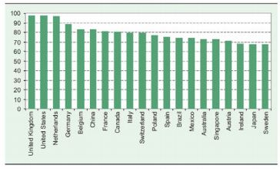
Figure 1 Location intensity of the 20 most preferred host economies, 2007 (number of firms)
Source: UNCTAD, 2008, P. 28

Further questions MNEs owners and/or manages ask include; should production be internalized or outsourced, and will transaction costs effect investment decisions and capital expenditures? Should expansion be horizontal or vertical? Horizontal expansion occurs; when the firm sets up a plant or service delivery facility in a foreign location with the goal of selling in that market; without abandoning production of the good or service in its home country, or if a firm invests in the same industry abroad in which it operates domestically. An example is Frito-Lay building a food production facility in China. Vertical expansion occurs if a firm invests in a supplier industry abroad, such as Apple building a phone assembly plant in Malaysia. All MNEs need to make two fundamental strategic decisions in order to ensure that they have a competitive advantage over purely domestic firms. The first is where to locate assets and employees. The second, whether to its operations dispersed in the foreign country needs to be managerially coordinated or not. While economic fundamentals alone are not enough to insure MNE success, identifying the intangible economic conditions and potential barriers is essential. An economic view of MNE types of expansion presents different conditions based on vertical and horizontal foreign investment as reflected in:

Table 2
The Economic View of the Multinational Enterprise (MNE)
Type of Foreign Expansion | Necessary conditions for the existence of the MNE | Sufficient conditions for the existence of the MNE
Vertical | - Cost & productivity of production factors (theory of comparative advantage) | - Asset specificity  - Uncertainty
Horizontal | - Transportation costs.  - Trade protectionism  - Exchange rate shifts.  - Need to customize. | - Intangible assets: patents, brands,  know-how, and other firm-specific skills
Adapted from: Richard E. Caves, Multinational Enterprise, and Economic Analysis. New York: Cambridge University Press, 1996

Additional considerations for MNEs require understanding of principles of cultural and sociopolitical issues, in particular, to the progression of bargaining power with the intended host government, labor unions and interest groups in the foreign country decision-making process as reflected in Table 3.

Table 3
The Bargaining Power of the Multinational Enterprise (MNE) relative to the Host Government in the Foreign Country
Case | Before Investing | After Investing
Extractive investments | Large & long-term investment helps MNE extract commitments from host government, unless there is competition to invest. | Balance of power shifts to  host government as it learns  about the production  process and investment cost  is sunk.
Import-substitution investments | MNE is weak because host  government can decide who  can establish operations  inside the protected market | Balance of power shifts to  MNE as it develops links to  Suppliers, buyers, and joint venture partners.
Export-oriented investments | Host government is weak if  labor cost is the locational  advantage; somewhat  stronger if investment is  capital-intensive | Balance of power does not  shift so long as locational  advantages do not change,  moreover, assets are mobile(e.g. machinery)
Adapted from: Stephan Haggard, Pathways from the Periphery. Ithaca: Cornell University Press,
1990, pp. 220-222.
It is imperative for MNEs to develop advantages investment decisions based on the host country domestic economic environment, the potential of the economy, combined with the balance of power based on the investment types necessary for the MNE strategy, all considering the financial capacity of the MNE, from small individual entrepreneurial approaches, to large multinational global brands. As an MNE evaluates potential host countries, FDI analysis provides numerous dynamics of the motives and intentions of host countries government’s policies and objectives. Those governments wishing to attract FDI include two forces:
- Agglomeration – similar producers tend to gather in one place
- Fragmentation – splitting of the production process
FDI is not an absolute requirement in becoming and MNE, fragmentation can provide different forms of a firm’s option regarding horizontal and vertical approaches as follows:

Table 4
Global Fragmentation without FDI
 | Same firm  (multinational) | Different firm  (not multinational)
Horizontal Fragmentation | Horizontal FDI | International Franchising
Vertical Fragmentation | Vertical FDI  International Sourcing | Offshoring

Effects of Foreign Exchange Translation and Exposure Risks
As MNE’s evaluate foreign markets, an understanding and strategy are necessary to address the effects of foreign exchange rate exposure. The effects of foreign exchange translation and exposure risks starts with the definition of foreign exposure as, “Foreign exchange exposure is a measure of the ability of a firm’s profitability, net cash flow, and the market value to change as a result of a change in exchange rates” (Shubita, Harris, Malindretos, & Bobb, 2011, p. 171). Foreign exchange translation measures the potential changes in a firms financial statements because of changes in foreign exchange rates. Three types of exposures include: (a) translation of accounting exposure, (b) transaction or contractual exposure, and (c) operating or economic exposure. Foreign exchange exposure is the sensitivity of the real domestic currency value of assets, liabilities, or operating incomes to unanticipated changes in exchange rates. Economic exposure quantifies the projected cash flow changes resulting from these foreign exchange rates. Transaction exposure results from changes in transaction values, due to changes in exchange rate values during the activity and the final accounting statements. Tools available to MNEs to minimize risk exposure due to exchange rate fluctuations include hedging instruments such as Forward Exchange Rate Contracts, Money Market Hedge, Futures, Options, and Swaps.
Risk management of currency through exchange rate exposures encompasses financial as well as operational hedges. Structuring cash flows incorporates operational competitiveness within the industry while managing financial exposure initiatives. Management policy strategy requires a diversified approach to operations in order to hedge against losses, using futures and forward contracts and additional currency options. Best and worst case scenarios for exchange rate fluctuations must be in place in order to reduce the overall risk associated with these instabilities.

Motives and Perspectives of Home and Host Governments, MNE’s and FDI

MNEs expansion strategy, by nature, rests on risk, investment, and opportunities in foreign markets. The world investment report from UNCTAD (2010) indicates that developed-country transnational corporations (TNCs) account for the bulk of global FDI. FDI is more a function of trade and investment rather than the financial perspectives side of international economics. Definitions of FDI vary, and are sometimes difficult to measure. The IMF, Balance of Payments Manual, 4th ed., 1977, p.136) definition of FDI for purposes of this examination is “Direct investment refers to investment that is made to acquire a lasting interest in an enterprise operating in an economy other than that of the investor, the investor's purpose being to have an effective voice in the management of the enterprise." Operationally, there are three types of FDI:
- Equity acquisition--buying shares of an existing or a newly created enterprise
- Profit re-investment--FDI firms re-investing their profits for further expansion
- Loans from a parent company
Most of global FDI remains in OECD economies and is unlikely to change, with around 30 per cent held in non-OECD economies (Molnar, Pain & Taglioni, 2008). The global financial crises has seen shifts of MNEs focus to developing and emerging economies, with a dramatic 43 per cent increase in 2008, particularly in Africa and South-East Asia. China remains the largest and still growing source of both inward and outward bound FDI. China accounted for 65 percent of inward international investment into emerging economies. MNEs appreciation of policies that affect FDI, are imperative. Research into each country, will provide insight into how governments think about foreign investment into their domestic economies, represented by examples in part in Table 5.

Table 5
Some examples of policy measures directly affecting FDI introduced after September 2008
Country | Measure | Relevant Features
Algeria | A fiscal measure introduced in the 2009 budget, January 2009 | A 15% tax will be levied on profits transferred abroad by foreign companies operating in Algeria
Canada | Amendments to the Investment Canada Act February 2009 | Some obstacles to FDI are relieved and the transparency of government decision is increased. Introduction of national security test on investments by Non-Canadian businesses.
Canada | Amendments to the Investment Canada Act February 2009 | Limits of foreign ownership in Canadian Airlines are raised from 25% to 49%
Columbia | Introduction of new capital-control measures (Sept. 008) | Affects short-term capital flows
India | Changes in FDI regulation, December 2009 | Larger share of foreign ownership in many activities such as industrial parks, mining and petroleum, air transport
India | Changes in FDI regulation, December 2009 | Facilitate application of caps on foreign ownership in strategic sector (defense, aviation, telecommunications.
Japan | Existing export insurance schemes for Japanese affiliates operating in developing countries have been extended to affiliates in developing countries. | Facilitates activities and trade of Japanese affiliates
Japan | Granting of business loans by Japan bank for Int. Cooperation (JBIC) to Japanese companies and their affiliates which operate in developed countries (March 2009), extension of loans that had been limited to those in developing countries | Facilitates activities and trade of Japanese affiliates abroad
Source: UNCTAD, 2009d, p.42
Notes. As can be seen, many countries talk about foreign investment growth, however, political parties and interests create obstacles that in fact, negatively affect investor optimism and belief in opportunities.

Trends in FDI inflows by grouped economies suggests developing countries offer the highest level of FDI to date as seen below:
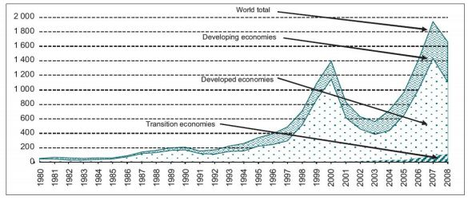
Figure 2 FDI inflows, global and by group economies, 1980-2008 (billions of dollars)
Source: UNCTAD, 2008, p.7)

MNEs also have to deal with considerations of home country motives, including regulations and other forms of restrictions. One example would be the US home country of an MNE and the Foreign Corruptions Practices Act of 1977, “enacted for the purpose of making it unlawful for certain classes of persons and entities to make payments to foreign government officials to assist in obtaining or retaining business”(The United States Department of Justice, n.d., Para. 1). Enterprises should observe the framework of applicable law, regulations and prevailing labor relations and employment practices, applicable international labor standards, and endeavor to participate accordingly. It is paramount that small companies as well as all other types of strategic alliances, do not fall into the trap of thinking foreign investment, foreign perceived corrupt practices, and other cultural and financial issues do not influence their market entry or expansion. Developing local knowledge partners and networking relationships provide a clearer understanding of the all-important cultural elements.

Three Challenges for MNEs

Management Practices – Management practices in foreign markets, in particular transition economies offer significant challenges beginning with market entry negotiations to ongoing business activities, in particular to the various aspects of vertical and horizontal types of organizational structure and human resources management (HMR). MNEs deal with multiple HRM approaches, whether in developing or developed economies. MNEs tend to be smaller, with fewer resources in emerging countries, than when entering developed countries. MNEs must carefully review budgets for expansion relative to human resources, research and management structures necessary for each individual country based on diversity and global economic maturity.
In the 21st century knowledge economy where services and creative industries dominate the economic landscape that is oriented more towards developing and transition economies, the theories and practices applicable to Western MNCs that monopolized the 20th century industrial economy are slowly but steadily giving way to new economic and management paradigms. (Thite, Wilkinson, & Shah, 2010, p. 289) MNE knowledge attainment needs to include the history of potential partners in addition to the industry and country history. The adaptation of management practices blends the home country standardization of strategic management tools, with a customized host market set of procedures and activities in order to compliment the general financial and market share goals of the parent company. The key enterprise strategy incorporates a MNEs balance of global HMR integration with the host country adaptation of cultural and institutional characteristics in a working system creating a productive alliance. The strategy includes adopting an ethnocentric approach to managing subsidiaries in foreign markets, expressed in the diagrammatic representation in Figure 3. The diagram indicates the internal and external factors influencing human resources strategy and practices.

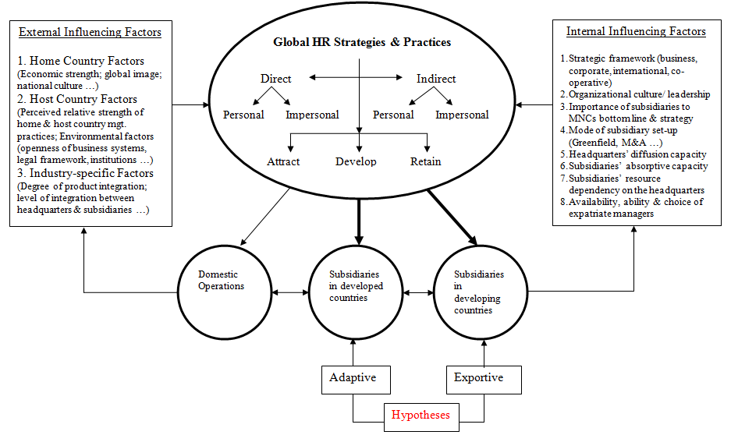
Figure 3 Diffusion of Global HR Strategies & Practices across Subsidiaries in a
Multinational Corporation from an Emerging Economy
Source: (Thite et al. 2010, p. 31)
An example of a company that understood the need for management practices that met all stakeholders needs, Carrefour, upon market entry into China, decided the best strategy for management adaptation was to find local partners, regionally within China, who were passive and uninterested in too much direct management control. The approach was to operate individual joint ventures for each region, resulting in 19 overall, the first 20 years of operations. Although some mistakes were made in joint venture partners, most succeeded, allowing Carrefour management time to learn what expectations and requirements were necessary for their partners, while learning the cultural and institutional management styles that met everyone’s needs.

Technology - Long-term requirements for success for an MNE and one of the most important assets of an MNE, is knowledge, which is gained from the combination of internal and external technology advancements, or technology transfer, through methods of demonstration (sharing of information with other firms), and competition (other firms present new and improved products or services, attracting market share increases). The benefits of technology transfer include the increase in knowledge of skills and/or how production processes enhance improvement. The internet supports technology transfer both internally and externally, and requires MNEs to maintain high-tech communications and management systems to remain competitiveness addressing creativity and innovation. MNEs by definition, control foreign entity operations, or management across national borders. This control requires technology management. Dunning’s OLI (ownership-location-internalization advantages) theory breaks down these components for managers to consider in structuring cross-border management. These theories are ever changing and maturing. Major MNEs like American Express, Hewlett-Packard, General Electric, HSBC and others, constantly reevaluate and adjust international operations based on gaining insight into the host country’s requirements and also as a result of new and updated technology, providing faster, more detailed knowledge for the decision making process. “The modern MNE uses information and communication technology (ICT) to mitigate transaction costs, and evolves more to arm’s length exchange to incentivize lower production costs” (Rangan & Sengul, 2009, p. 1496). However, lower production costs are only some of the benefits; others include more intimate connection to partners, suppliers and customers.
Transfer of knowledge, while relying on technology as mentioned above, also requires the right environment between the home and host country, between corporate headquarters and the subsidiaries as to openness, and absorptive capacity. MNE business models should incorporate the important components of knowledge transfer as part of the he structural dimensions, described as knowledge transfer to subsidiaries represented in Figure 4.

Figure 4 Structural dimensions of the transfer of knowledge
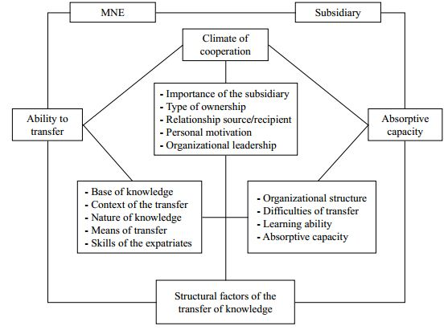
Source: (Martins & Nelson, 2010, p. 519)
Technology transfer also effects ongoing changes within the chosen host country, through the development and improvements of other emerging countries that may well create competition and require changes in medium to long-term strategies. As countries improve their global competitiveness, as their standard of living improves, wages and sometimes inflation follow. Nations build on growing technological advancement, through research and development, profits converted to R & D, leading to innovation and creativity. MNEs may start with one foreign country and decide movement to another is necessary.
Siemens, a German MNE moved much of its mobile phone development to China in an attempt to become more cost competitive. The Chinese facility was successful in developing mobile phones for Asian consumers, but Siemens was never able to gain a strong foothold in the China market. The technology transfer was successful in the respect it lowered production cost; however, the mistake made was the weak research into the China government controlled domestic mobile networks, which prohibited foreign entry. Enterprise strategy for this example points to the need to differentiate technology transfer into production and marketing segments, separately analyzed and evaluated as each can provide benefits and risks. Simple cost-benefit analysis is not enough! “At one firm top management had simply mandated that a certain percentage of technology development be offshored; our respondents said this was in response to Wall Street expectations that more offshoring always results in lower costs”(Leonard & Salzman, 2008, p. 79). This simply points out the fact that Wall Street is not the ultimate decider of what management should endeavor to satisfy, but more directly, what is in the best interest of the customer and the firm, remains the paramount issue.

Cultural Diversity – MNEs of all sizes face numerous challenges regarding cultural diversity, in particular, the uncertainties of partnership and relationship management in developing countries. Management control of foreign offices or entities requires tolerance and/or local knowledge and understanding of differences in foreign management style as to the many alliances normally conforming to stakeholders and their special interests. “For example, the literature suggests, that while Chinese culture fosters societal conservatism, US culture encourages a competing style toward self-enhancement” (Morris et al., 1998). Additionally, as it relates to China and cultural diversity, the issue of “Guanxi” arises. Guanxi is the system of social networking, building alliances and developing mutual trust. In-spite of China’s vast opportunities for MNE development, the surprisingly small number of MNEs in China is directly attributed in many cases to the lack of understanding of MNEs in the causes and effects of Guanxi. Additional to the differences in approaches to business, mentioned above, the business strategies in China reflect not only Guanxi, but also Confucianism, leading to the view as business strategy is based on an adversarial relationship, founded on Sun Tzu’s “Art of War”. The western “win/win” strategy is not a primary component of Chinese business manager’s arsenals for negotiation.
Managers of international partnerships who adjust quickly to the institutional and cultural environments in which they operate are destined for success. Knowledge about the influence of non-market factors in partnership management offers the potential for those managers to create significant competitive advantage for their enterprises going forward in an emerging market economy. (Chen & Li, 2009, p. 723) This cultural diversity influences all areas of MNE interactions including employment, partnership, negotiations, marketing, balance of payments, accounting, legal and regulatory, or governmental involvement. Walmart spent 12 years, in China, achieving an annual revenue of over $11 Billion U.S., while still losing money. Even though Walmart is a great example of a company that does its due diligence before entering a foreign market, they made significant errors in judgment regarding cultural diversity such as:
- Poor projections of shopping traffic standards, including the first store opening, where over 1 million shoppers lined up for the opening. The store specification designs, having followed US standards, were not ready for the opening crowds, or daily shopping traffic. The aisles specified as per US opening shopping patterns, approximately 50,000 average opening-day shoppers resulted in uncontrollable crowds, followed by daily unmanageable customer traffic.
- Wet markets, not a segment in the U.S. consumer pattern, in China, include live animals, fish, frogs, snakes etc. These products therefore had to be sourced from local vendors, with store designs updated to present these new categories of assortments and the daily care required.
- Improper fashion trend projections, based on colors, size specifications, and product development. Many cultural fashion peculiarities of the Chinese consumer were overlooked. Inventory assortments, replenishment and store presentations all needed updating.
- The combination of income disparity in China, and government regulations that would not allow Walmart to build more than three stores in one city, had a much deeper effect on market share than Walmart originally calculated, slowing growth, reducing some of the corporate marketing and economies of scale models.

The challenges MNEs face regarding cultural diversity influence potential success and/or can be damaging if not addressed from the time of initial research into a foreign market, but constantly along the way concerning strategic planning, implementation, and ongoing business activities. Enterprise strategy of the joining of ethical and strategic thinking about the organization and it aligns organizational behavior and strategies to standards, norms and expectations in the foreign environment. It is the strategy level where the social and political characteristic should include good corporate social responsibility (CSR), considering all stakeholders.

Conclusion
In summary, a road map for MNE market entry requires review of all aspects of a global business from perspectives of management of host and home countries covering all stakeholders’ needs. MNE’s, regardless of size, should study, understand, and follow the OECD guidelines, and developed by the member governments, whether for OECD country development or non-member national market entry for operating within these foreign markets. Risk factors associated with economic, political, legal, financial, cultural, and institutional, require research and strategic development. MNE’s should follow certain fundamental economic, strategic, organizational, sociopolitical principles. Careful attention to international economic theories, policies and variables, causes and effects of same, are of paramount importance in the decision making process. International organizations, market and trade opportunities, and barriers require scrutiny. The involvement of each section of an MNE, marketing, finance, sales, production, and human resources are important and necessary in the foreign expansion process.

References
Boyles, W., & Melvin, M. (2008). Economics (7th ed.). Boston, MA: Houghton Mifflin Company.
Carbaugh, R. J. (2010). International Economics (13th ed.). Florence, KY: South-Western.
Chen, D., & Li, D. (2009). Non-market factors and partnership management in transitional economies. Management Research Review, 32(8), 716-727. doi: 10.1108/01409170910977933
Guillen, M. F. (2011). Understanding and Managing the Multinational Firm (Doctoral dissertation, The Wharton Scholl of the University of Pennsylvania). Retrieved from http://www-management.wharton.upenn.edu/guillen/files/mneconcept.pdf
Leonard, L., & Salzman, H. (2008). Multinational and the Globalization of Technology Development. Retrieved from http://policy.rutgers.edu/faculty/salzman/MNE%20Global%20Tech-Effective%20Exec-3-08.pdf
Markey, R., & Ravenswood, K. (2009). The effects of Foreign Direct Investment and multinational enterprises on the areas covered by the 1977 MNE Declaration of the ILO. Retrieved from http://www.ilo.org/wcmsp5/groups/public/---ed_emp/---emp_ent/---multi/documents/publication/wcms_117580.pdf
Martins, J., & Nelson, A. (2010). Knowledge transfer to the subsidiaries operating in overseas. Industrial Management + Data Systems, 110, 516-531. doi: 10.1108/02635571011039007
Morris, M., Williams, K. Y., Leung, K., Mendoza, R., Ghatnagar, M. T., Li, D., Hu, J. (1998). Conflict management style: Accounting for cross-cultural differences. Journal of International Business Studies, 29, 729-748.
OECD Guidelines for Multinational Enterprises. (2011). Retrieved from http://www.oecd.org/dataoecd/43/29/48004323.pdf
Rang an, S., & Sengul, M. (2009). Information technology and transnational integration: Theory and evidence on the evolution of the modern multinational enterprise. Journal of International Business Studies, 40(9), 1496-1514. doi:10.1057/jibs.2009.55
Shubita, M. F., Harris, P., Malindretos, J., & Bobb, L. M. (2011). Foreign Exchange Exposure: An Overview. International Research Journal of Finance and Economics, 78, 171-177. Retrieved from http://www.internationalresearchjournaloffinanceandeconomics.com/ISSUES/IRJFE_78_13.pdf
The United States Department of Justice. (n.d.). http://www.justice.gov/criminal/fraud/fcpa/
Thite, M., Wilkinson, A., & Shah, D. (2010). International & HRM Strategies across Subsidiaries in Multinational Corporations from Emerging Economies. Retrieved from www.shrm.org/.../documents/thite%20final%20report%204-11.doc

ABOUT THE AUTHORS
Steve Clarke (MBA, PhD, ABD) is Senior Consultant and Advisor to the Global Management Group (www.globalmanagementgroup.com), a leading consulting firm that helps US companies and executives succeed in Asia. He has consulted for Fortune 500 companies and has extensive experience in the China market. In addition, he has more than 25 years of experience in International Business at Federated Department Stores (Macy’s, Bloomingdales), May Department Stores, Carter Hawley Hale Department Stores, Eddie Bauer, National Football League (NFL), Arnold Palmer Golf Design, Central Department Stores (Thailand), Robinson Department Stores (Philippines), and #1 Department Store (China). He has also been a successful entrepreneur founding China Silk Wines, in addition to consulting foreign companies entering the Asian market. He has taught international business classes including, strategy, ethics, social media, foreign market entry, marketing, economics, organizational behavior, operations management brand development. He is a graduate of Northern Arizona University and Grand Canyon University. He is currently senior consultant for Global Management Group, International Consultants and is guest business analyst on the Nation, Sunday Night Business weekly television in Bangkok Thailand.
Professor Peng Chan (PhD) is Full Professor of Strategic Management at Cal State Fullerton. He has published widely (200+ articles) in the fields of strategy, franchising, and international business and has over 25 years’ business and consulting experience in the US and the Asia Pacific region. Dr. Chan is founder and CEO of Global Management Group (www.globalmanagementgroup.com).

